**DAILY ONLINE ACTIVITIES SUMMARY**

|  |  |  |  |  |  |
| --- | --- | --- | --- | --- | --- |
| **Date:** | | **14/06/2020** | | **Name:** | **KHATHEEJA SAFREENA.** |
| **Sem & Sec** | | **4th & ‘A’** | | **USN:** | **4AL18CS037.** |
| **Online Test Summary** | | | | | |
| **Subject** | **-------------** | | | | |
| **Max. Marks** | **--------------** | | **Score** | | **-------------** |
| **Certification Course Summary** | | | | | |
| **Course** | | **Introduction to Cyber Security.** | | | |
| **Certificate Provider** | | **Great learning.** | **Duration** | | **6 hours.** |
| **Coding Challenges** | | | | | |
| **Problem Statement:1)** Write a C program to remove specific characters in the String | | | | | |
| **Status: complied** | | | | | |
| **Uploaded the report in Github** | | | **yes** | | |
| **If yes Repository name** | | | **[http://shafreenasharief / lockdown-coding](http://shafreenasharief / lockdown-coding" \o "http://shafreenasharief / lockdown-coding)**  **[http://shafreenasharief / locked-down--certification-course](http://shafreenasharief / locked-down--certification-course" \o "http://shafreenasharief / locked-down--certification-course)**  **[http://shafreenasharief / Daily\_Report](http://shafreenasharief / Daily_Report" \o "http://shafreenasharief / Daily_Report)** | | |
| **Uploaded the report in slack** | | | **yes** | | |

Certification Course Details: (Attach the snapshot and briefly write the report for the same)

Coding Challenges Details: (Attach the snapshot and briefly write the report for the same)

**CERTIFICATION COURSE SUMMARY**:

Today I started new course INTRODUCTION TO CYBER SECURITY through GREAT LEARNING the course is secluded for 6hrs. After the completion of course, certificate will be provided. I completed all the module .I attempted quiz ,which gave me a clear veiw about the topics that were thought and discussed.It consists of 7 modules which also include assessments.

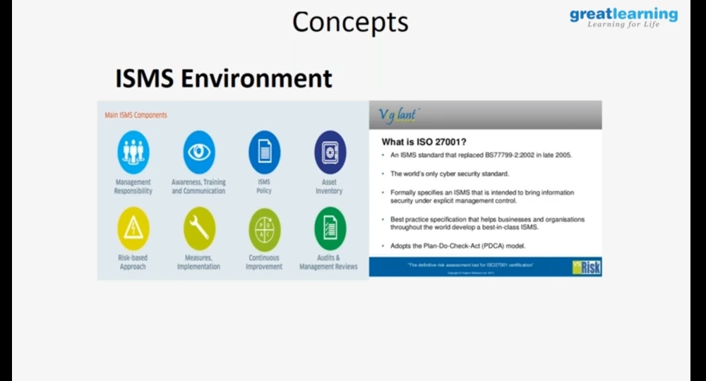

**CODING CHALLENGES**:

Today I solved coding challenge,

**PROBLEM STATEMENT**: Write a C program to remove specific characters in the String

Example  
If the original string is "Welcome to AIET" and the user inputs string to remove "co" then the it should print "Welme to AIET" as output .

**Input**  
First line read a string  
Second line read key character to be removed.

**Output**  
String which doesn't contain key character

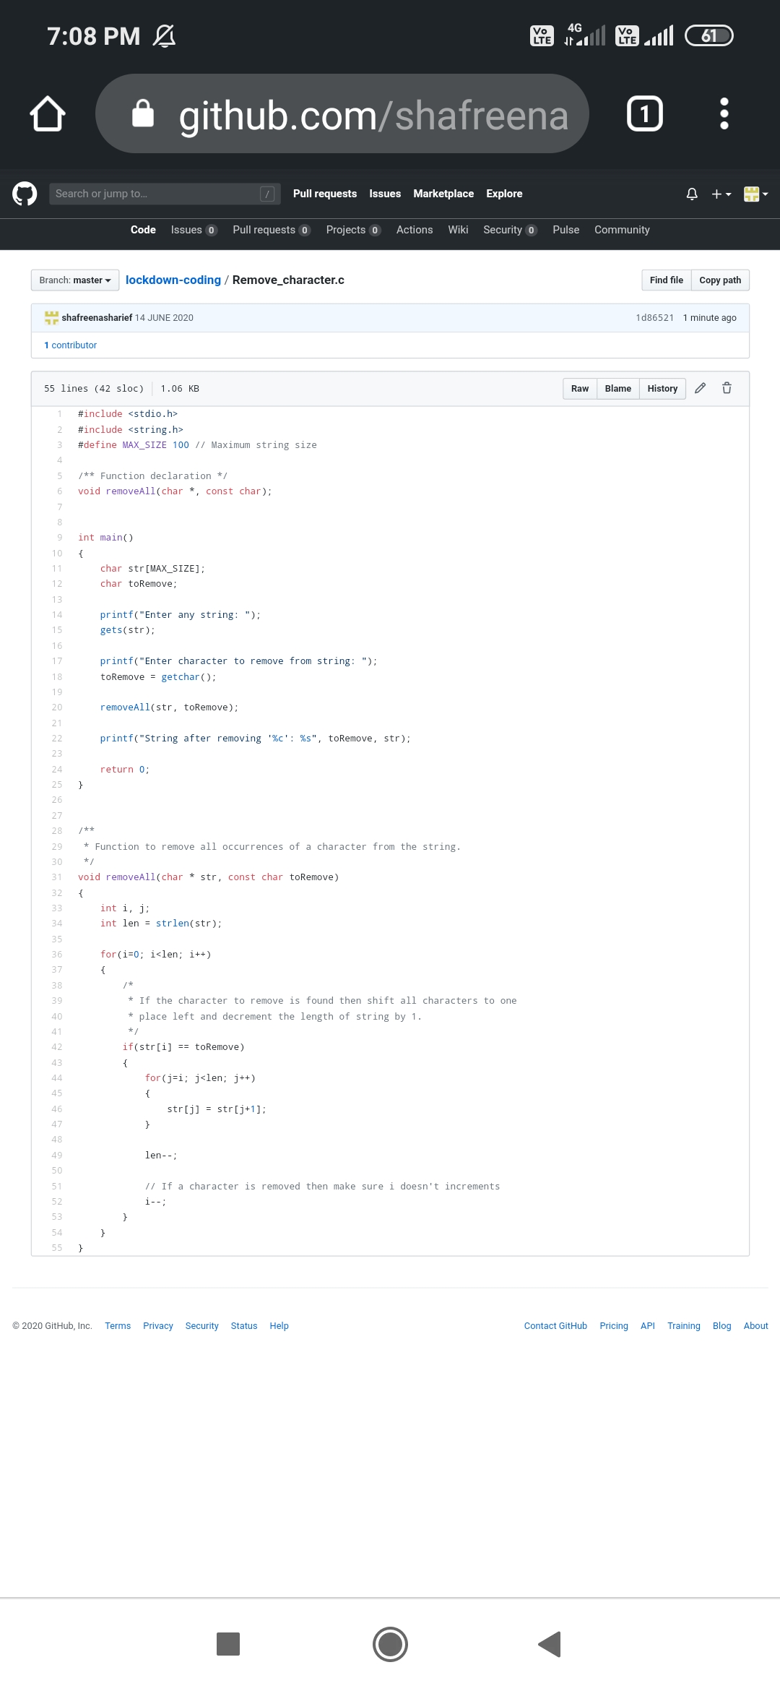

**EXTRA ACTIVITIES:**

I attended **E-Quiz on PYTHON** Organized by Department of computer science and engineering by College of Engineering, Nashik which was conducted on 13/6/2020 securing 100% . The e-certificate is been provide on 14/06/2020.

**There is the snapshot of the e-certificate.**

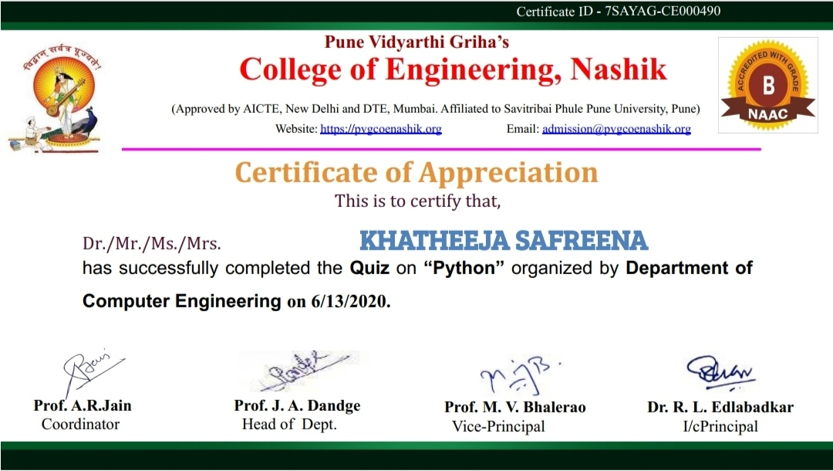

**SOLUTION** : I have uploaded the solution of the above 3 coding problems in my GitHub repository.

[http://shafreenasharief / lockdown-coding](http://shafreenasharief / lockdown-coding" \o "http://shafreenasharief / lockdown-coding)

[http://shafreenasharief / locked-down--certification-course](http://shafreenasharief / locked-down--certification-course" \o "http://shafreenasharief / locked-down--certification-course)

[http://shafreenasharief / Daily\_Report](http://shafreenasharief / Daily_Report" \o "http://shafreenasharief / Daily_Report)